1. create a SSIS package the send mail by sql server table details   
2. create a SSIS package that display below column from orders table  
   customer name | first Order Date |Latest Order Date | total Orders | total Quantity   
3. Create a SSIS package the display every year wise total customer ,Total Orders and total sale

1. create a SSIS package the send mail by sql server table details

Ans:

Execution:

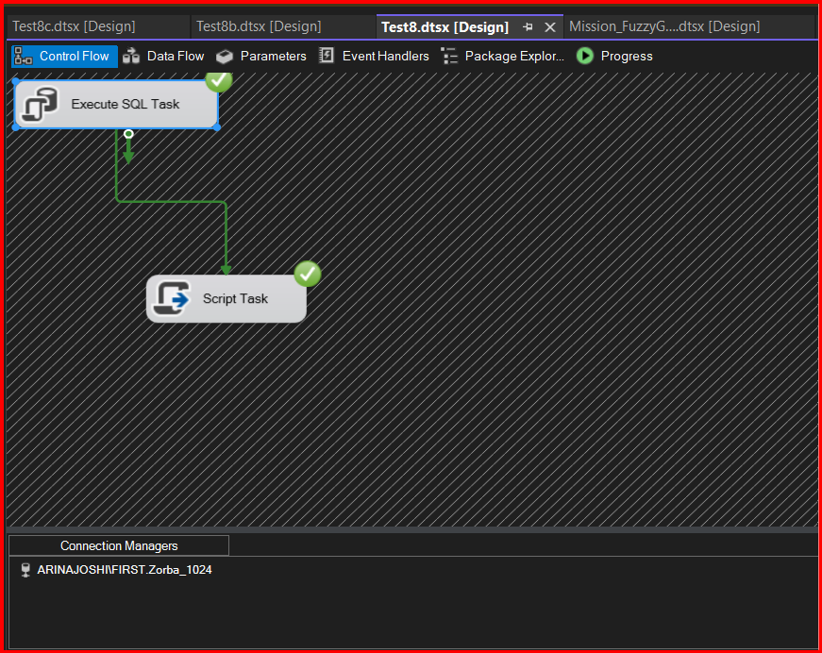

2. create a SSIS package that display below column from orders table  
   customer name | first Order Date |Latest Order Date | total Orders | total Quantity

Ans: Execution:

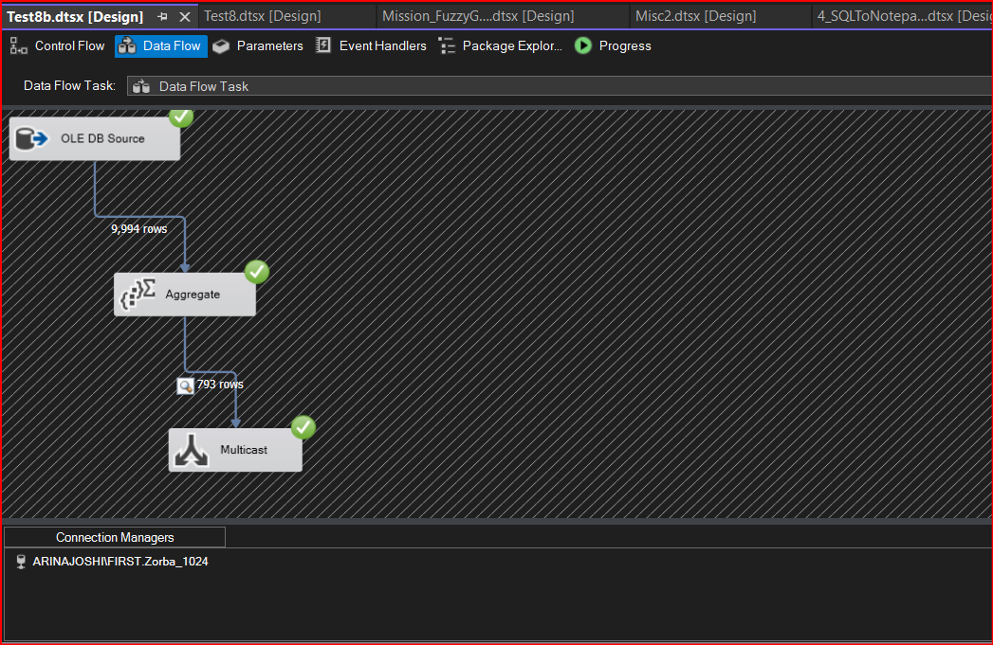

Output:

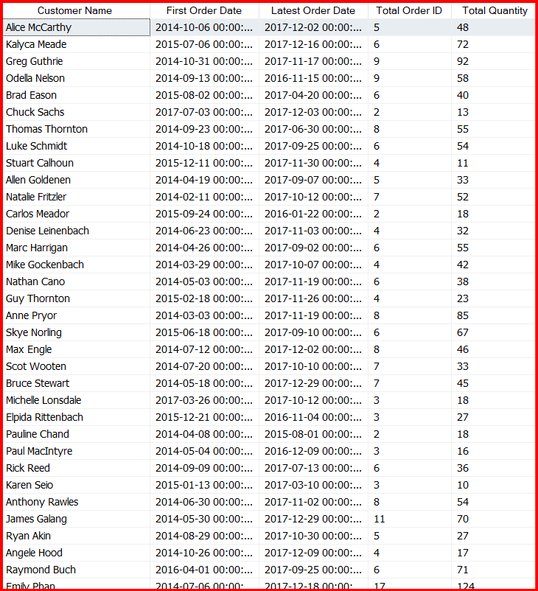

1. Create a SSIS package the display every year wise total customer ,Total Orders and total sale

Ans:

Execution:

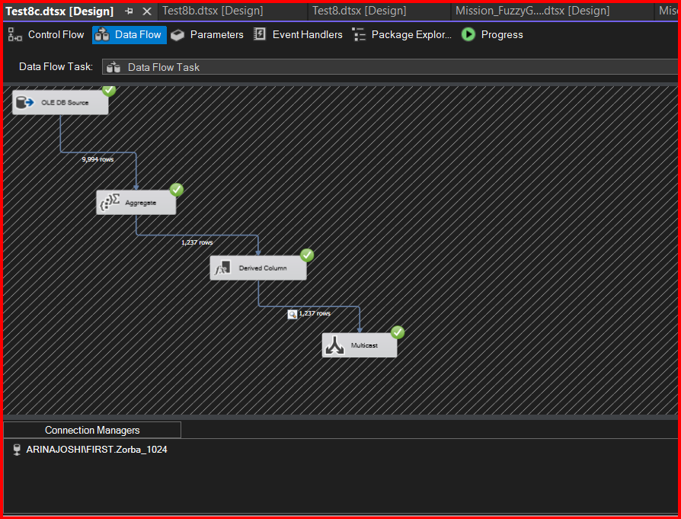

Output:

